The breakdown of glucose by enzymes, releasing energy and pyruvic acid
A. Glycolysis
B. Citric Acid (Krebs) Cycle
C. Electron Transport Chain
D. Chemiosmosis
ANSWER: A
A _________from the hydrolysis of a molecule of ATP is added to glucose, a 6-carbon sugar, to form glucose 6-phosphate
A. Nitrogenous base
B. Phosphate
C. Carbon ring
D. Isomer
ANSWER: B
The glucose 6-phosphate molecule is rearranged into fructose 6-phosphate is:
A. Phosphorylation
B. Isomerization
C. Decarboxylation
D. Splitting
ANSWER: B
When fructose-6-phosphate reacts with another ATP, it is phosphorylated to Fructose-1, 6-bisphosphate
A. Phosphorylation
B. Isomerization
C. Decarboxylation
D. Splitting
ANSWER: A
Fructose-1, 6-bisphosphate splits up to form one molecule each of 3-carbon compounds:
A. Glyceraldehyde 3-phosphate
B. G3P
C. Dihydroxyacetone 3-phosphate
D. All of these
ANSWER: D
The dihydroxyacetone 3-phosphate is ultimately changed into _________, the glyceraldehyde 3-phosphate (G3P)
A. Epimer
B. Isotope
C. Isomer
D. Conformer
ANSWER: C
Glycolysis also called:
A. ETC
B. EMP
C. Calvin cycle
D. TCA
ANSWER: B

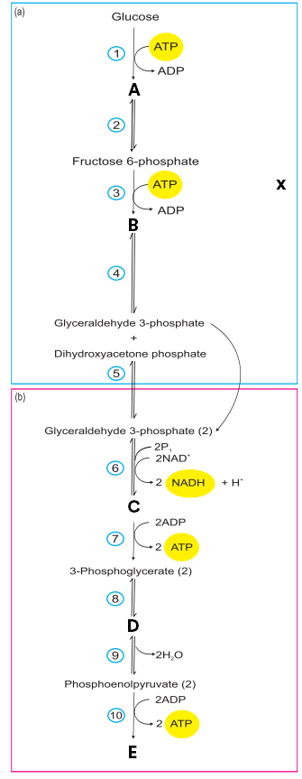
What phase does X represent in the given diagram?
A. Preparatory phase
B. Pay of phase
C. Cis face
D. Trans face
ANSWER: A

This is the diagrammatic representation of:
A. Glycolysis
B. Citric Acid (Krebs) Cycle
C. Electron Transport Chain
D. Chemiosmosis
ANSWER: A

Observe the diagram and identify A
A. 2-phosphoglycerate (2)
B. 1,3-bisphosphoglycerate (2)
C. Fructose 1,6-bsiphosphate
D. Glucose 6-phosphate
ANSWER: D
Observe the diagram and identify B

A. 2-phosphoglycerate (2)
B. 1,3-bisphosphoglycerate (2)
C. Fructose 1,6-bisphosphate
D. Glucose 6-phosphate
ANSWER: C
Observe the diagram and identify C

A. 2-phosphoglycerate (2)
B. 1,3-bisphosphoglycerate (2)
C. Fructose 1,6-bisphosphate
D. Glucose 6-phosphate
ANSWER: B

Observe the diagram and identify D

A. 2-phosphoglycerate (2)
B. 1,3-bisphosphoglycerate (2)
C. Fructose 1,6-bisphosphate
D. Glucose 6-phosphate
ANSWER: A
Observe the diagram and identify E

A. 2-phosphoglycerate (2)
B. Pyruvate (2)
C. Fructose 1,6-bisphosphate
D. Glucose 6-phosphate
ANSWER: B
Glycolysis occurs in the ______of the cell
A. Cytoplasm
B. Mitochondria
C. Chloroplast
D. Ribosome
ANSWER: A

